PROJECT DOCUMENTATION

* The following project is AUTOMATED STREET LIGHTNING SYSTEM USING IOT.
* The project is based on light sensor (LDR) which switches the street lights as either in ON or OFF condition.
* The NodeMCU is interfaced to the Basic Shield in which it having LDR & LED (as street lights) components.
* The Circuit Diagram of desired Automated Street Lightning System is here;
* 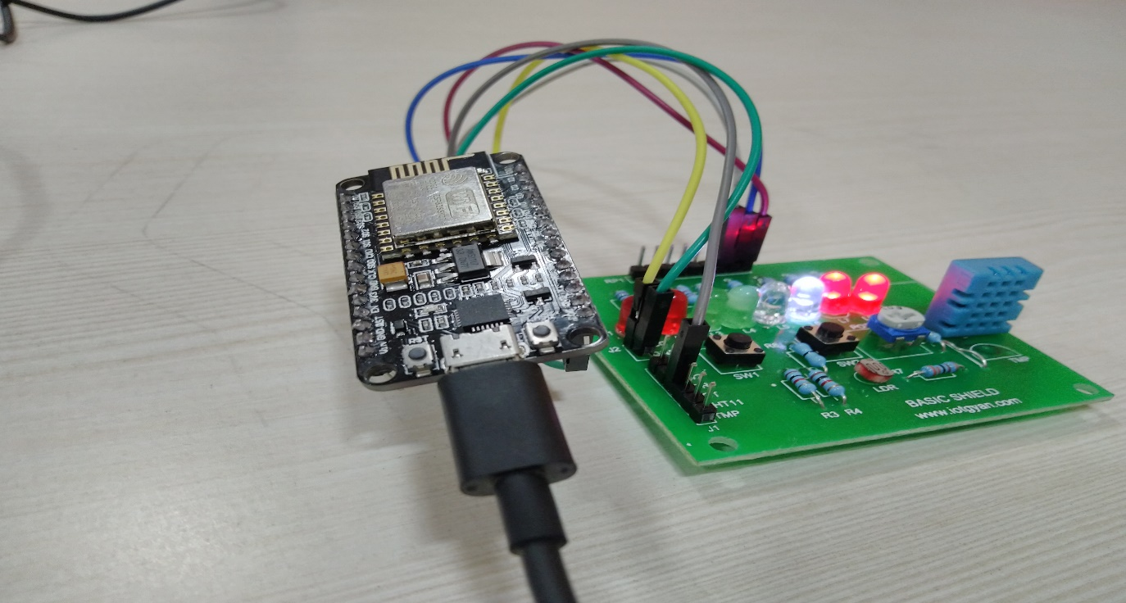
* The Output Results is captured and it is stored in IBM Watson Cloud.
* Here, Light Dependent Resistor (LDR), acts as light sensor.
* When no lights falling on the LDR, its resistance decreases, so as the street lights switches, operated in ON mode.
* Simantaneously, when lights falling on the LDR, its resistance increases, so as the street lights switches, operated in OFF mode.
* The Output shown in Node-RED shows in two ways , First the LDR resistance is shown in Gauge, depending on the intensity of light falling on (LDR).
* And, Second is the Notification which shows the desired notification as street lights as either in ON / OFF condition.

